

**The role of the meninges in optic pathway development**

Hristina Stefanova

Student ID: 51442880

Project Supervisor: Professor Lynda Erskine

Word count: 5209

Thesis presented for the degree of MSci Neuroscience with Psychology at the University of Aberdeen

# Declaration

I hereby declare that all work described in this thesis was carried out by me together with my lab partner, Agne Dambrauskaite, and that I have analysed the results and written this thesis independently with all work and contributions duly acknowledged and cited.

Hristina Stefanova

May 2020

# Acknowledgements

I would like to thank all my teachers for creating a wonderful university experience. I am especially grateful for the support and understanding of Professor Lynda Erskine and Dr Derryck Shewan during this difficult for me time. Thank you to Le Viet Hang, who guided us through the lab procedures. Last but not least, I was extremely lucky to have my friend Agne Dambrauskaite as my lab partner, thank you for sharing this time with me.

# Contents

Abstract 5

Abbreviations 6

Introduction 8 – 17

Aims 18

Materials and Methods 20 – 24

Results 25 – 34

Discussion 35 – 39

References 40 – 48

# Abstract

The optic pathway is a very good model for studying axon guidance due to the multiple decision points axons navigate through during its formation. The optic pathway develops at the ventral surface of the brain in close proximity to the meninges. The meninges are highly vascularised tissue, secreting a variety of factors – good candidates for axon guidance cues.

Expression of the meningeal factors semaphorin-6A (*Sema6A),* insulin-like growth factor 2 (*Igf2*), transforming growth factor beta 1 (*Tgf-b1*) and bone morphogenetic protein 7 (*Bmp7*) was investigated in coronal sections of mouse embryo heads at midpoint of optic chiasm formation (E15.5) using *in situ* hybridisation. Existing *in situ* data for *Sema3A* was also analysed. Additionally, retinal explants of mouse embryos (E15.5) were cultured with or without meningeal explants to see the direct impact of meninges on axonal outgrowth.

*Igf2, Tgf-b1, Bmp7, Sema6A* and *Sema3A* were all expressed in the ventral meninges. All factors except *Sema3A* were expressed in the ventral diencephalon adjacent to the optic chiasm, making them good targets for further investigation. *Igf2* and *Bmp7* expression patterns suggested presence in the suprachiasmatic nucleus (SCN). Novel double fluorescent *in situ* method was designed to confirm this using the SCN marker *Rorα.* Unfortunately, the *Rorα* staining was unsuccessful and protocol refinement is required for conclusive results. Despite previous data, showing increased outgrowth from dorsonasal retinal explants in the presence of meninges, the meninges did not influence the outgrowth from the ventrotemporal or the dorsotemporal explants.

# Abbreviations

Bmp7 – bone morphogenetic protein 7

Bmpr1b – Bmp receptor 1b

CSPGs – Chondroitin sulfate proteoglycans

Cxcl12 – C-X-C motif chemokine 12 (SDF1)

DCC – deleted in colorectal carcinoma

HSPGs - heparan sulphate proteoglycans

Igf2 – insulin-like growth factor 2

NCAM – neural cell adhesion molecule

RGCs – retinal ganglion cells

Robo – roundabout

ROCK – Rho-associated protein kinase

Rorα – related orphan receptor alpha

SCN – suprachiasmatic nucleus

SDF1 – stromal cell-derived factor 1 (Cxcl12)

Sema – semaphorin

Sfrp - secreted frizzled related proteins

Shh – sonic hedgehog

Srfp – Secreted frizzled related proteins

Tgf-b1 – transforming growth factor beta 1

VEGF-A – vascular endothelial factor A

Zic – zinc finger of the *c*erebellum

# Itroduction

The optic pathway is a valuable model for studying axon guidance for several reasons: It is clearly defined and easily observed at the ventral surface of the brain. There is a single major neuronal subtype – the retinal ganglion cells (RGCs) relaying sensory information from the eyes to the brain, limiting potential confounding variables. Finally, the optic pathway has complex structure with RGC axons growing through multiple decision points towards the brain (Fig. 1). Many guidance cues (discussed below) involved in the optic pathway formation have already been uncovered (Herrera, Erskine and Morenilla-Palao, 2019), however, there is much that still needs to be investigated. One such example is the role of the meninges in the optic pathway development. The meninges are highly vascularized tissue which secretes variety of factors in close proximity to the developing brain tissue making it an ideal vector for guidance signals (Suter, DeLoughery and Jaworski, 2017). Some meningeal factors such as the stromal cell-derived factor 1 – SDF1 (Xiang *et al.* 2002), bone morphogenetic proteins – BMPs (Yam and Charron, 2013), transforming growth factors – TGFs (Dasgupta and Jeong, 2019), Semaphorins – Semas (Raper, 2000) and insulin-like growth factor 2 – IGF2 (Ziegler et al., 2012) have already been implicated in nervous system development. Those factors were further investigated here for their potential roles in the optic pathway formation.

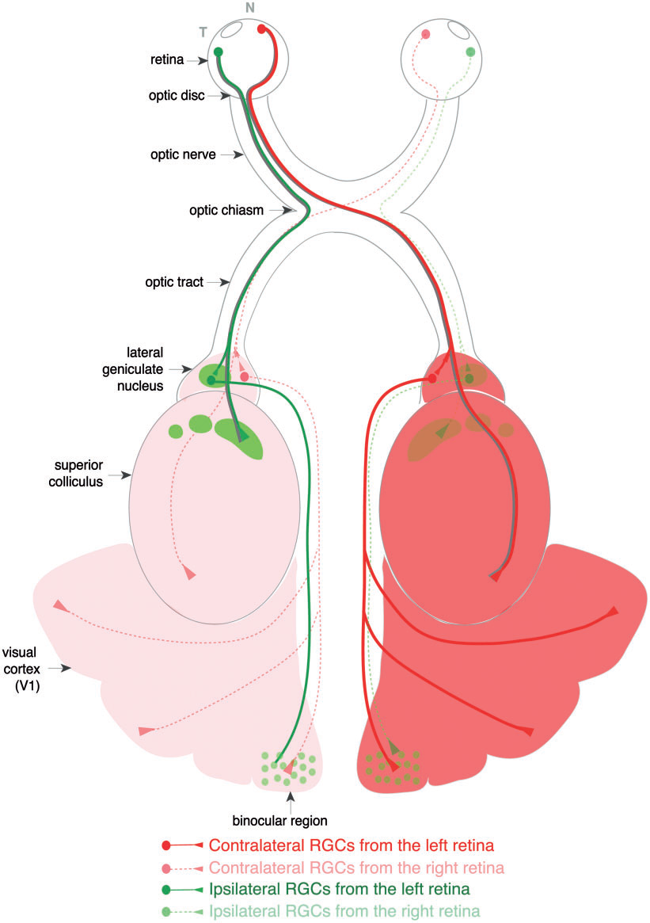

**Figure 1. Optic pathway (mouse).** Retinal ganglion cell axons travel from the retina, through the optic disc, via the optic nerve, to the optic chiasm. There, they continue either contra or ipsilaterally to the optic tract and the higher visual centers. Taken from Erskine and Herrera (2014).

## Optic pathway structure and development

The cell bodies of RGCs are located in the neural retina. RGC axons grow through multiple decision points. They (1) grow to the optic fibre layer at the inner surface of the retina, (2) extend to the optic disc, (3) exit the eye, (4) grow to the optic chiasm where, in species with binocular vision, they chose to either project contralaterally crossing the ventral midline of the brain or project ipsilaterally, and finally, (5) reach the primary visual centers of the brain – superior colliculus and lateral geniculate nucleus in mammals (Herrera, Erskine and Morenilla-Palao, 2019).

(1) Extension to the optic fiber layer

The first step in RGC axon pathfinding is extension to the optic fiber layer. This is achieved via combination of repulsive signalling from the inner retina and the attractive properties of the optic fiber layer. At the optic fiber layer axonal growth is stimulated by glial endfeet (Stier and Schlosshauer, 1995) and the neural cell adhesion molecule – NCAM (Halfter *et al.*, 1987; Brittis *et al.*, 1995). The inner nuclear layer of the retina secretes inhibitory molecules – Slits, which act on roundabout 2 (Robo2) receptors present on most RGCs preventing axons from growing into the retina. Disrupting Slit/Robo2 signalling leads to aberrant axon outgrowth into the retina (Thompson *et al.*, 2006, 2009). Secreted frizzled related proteins (Sfrp) also play a role in preventing aberrant growth into the retina. Sfrp elimination shows phenotype similar to Slit/Robo disruption with axons growing into the retina (Marcos *et al.*, 2015). A planar cell polarity protein expressed by the RGCs – Vangl2 also plays an important role in guiding axons at this stage. RGCs axons of mice deficient in this protein grow through the retina and accumulate at the subretinal space (Leung *et al.*, 2015).

(2) Reaching the optic disc

RGC axons grow towards the optic disc even in mouse models with defective growth into the optic fiber layer (e. g. Slit1/2 or Robo mutants, see Thompson *et al.*, 2006). No long range guidance cue has been identified – attractive and repulsive gradients are thought to guide the axons centrally. Chondroitin sulfate proteoglycans (CSPGs) wave moving from the center to the periphery controls RGCs generation (Brittis *et al.*, 1992)and together with Slit2 secreted from the lens repulse axons away from the retinal periphery (Thompson *et al.*, 2006). At the same time, sonic hedgehog (Shh) expressed in gradient with high central concentration decreasing towards the outer retina, attracts the axons centrally. Disruption of Shh signalling leads to random growth of RGC axons (Kolpak, Zhang and Bao, 2005).

(3) Exiting the eye

Netrin-1 expressed by the glial cells at the optic disc attracts the RGC axons via the DCC (deleted in colorectal carcinoma) receptor (Torre *et al.*, 1997). Lack of Netrin/DCC signalling leads to small optic nerves due to axons failing to exit the eye (Deiner *et al.*, 1997). Defects in BMP receptor 1B (mouse models) also lead to impaired exit from the eye (Liu, Wilson and Reh, 2003). For axons to complete the exit the initial attractive signal of netrin-1 needs to be overcome. This is potentially achieved by laminin-1 modulating cAMP levels in RGC growth cones and converting the attraction signal of Netrin-1 to repulsion (Hopker *et al.*, 1999). Ephrin B (EphB) signalling appears to also be important for optic disc exiting of dorsal (but not ventral) RGC axons with 33% of EphB2 EphB3 double null mutants showing disrupted pathfinding at the optic disc (Birgbauer *et al.*, 2000).

(4) Optic chiasm

After exiting the eye the RGC axons grow through the optic nerve to the optic chiasm guided via contact inhibition by Slit2 (Plump et al., 2002) and Sema5A (Oster, Bodeker, He and Sretavan, 2003) encasing the nerve, preventing axons from wandering. The optic chiasm is the crossover point for optic pathway neurons. Slits are present around the tracks leading to the chiasm but are absent from the midline where axons cross. In the absence of Slit signalling axons wander away from the path or cross into the wrong nerve (Plump *et al.*, 2002). In species with binocular vision, some axons, originating specifically from the areas of visual overlap in the retina, do not cross and instead make a 45° turn and project ipsilaterally (Jeffery and Erskine, 2005). The amount of ipsilateral projections depends on the extent of binocular vision. In rodents, only 2-3% of neurons (originating from the peripheral ventrotemporal region of the retina) project ipsilaterally (Cowey and Perry, 1979) while in primates who experience superior binocular vision and depth perception up to 45% of neurons (from the temporal retina) project to the same side (Fukuda *et al.*, 1989; Jeffery and Erskine, 2005). Ipsilateral and contralateral projections are (at least partially) sorted via interactions with molecules expressed at the ventral midline such as vascular endothelial growth factor A (VEGF-A) and Ephrin B2. Neuropilin-1 a receptor for VEGF-A is specifically expressed on the axons that are destined to cross the chiasm an example of chemoattractive guidance (Erskine et al., 2011). Lack of Neuropilin-1 leads to failure of axons to normally cross the chiasm (Erskine *et al.*, 2011, 2017). Ipsilateral axons, on the other hand, express the Zic2 transcription factor (Wang, Marcucci, Cerullo and Mason, 2016) which in turn induces the EphB1 receptor, which senses the repulsive signal of Ephrin B2 (Escalante *et al.*, 2013). Enhancement of Zic2 leads to increased number of ipsilateral projections, while EphB1 knockout leads to decreased ipsilateral projections (Garcia-Frigola *et al.*, 2008).

## Meninges and meningeal factors

Guiding the RGC axons though the developing optic pathway is incredibly complex and only some of the mechanisms and guidance cues have been discovered. There are many more molecules potentially playing a role in this process. Furthermore, multitude of tissues are interact in eye and brain development – neural tissue, ectoderm, crest cells, mesenchyme – each capable of secreting various signals to influence the developing system. The meninges are one of the tissues of interest due to their capability to secrete variety of factors in close proximity to the developing neuronal structures.

One such example is stromal cell-derived factor-1 – SDF-1 (or C-X-C motif chemokine 12 – Cxcl12). In the developing nervous system SDF-1 functions as a chemoattractant signal regulating proliferative cells (granule layer beneath the meninges; Klein *et al.*, 2001) and stimulating migration of cells such as Cajal-Retzius cells and inhibitory interneurons (Marin and Rubenstein, 2003; Metin *et al.*, 2006). Additionally, SDF-1 functions as axon guidance molecule. Rat cerebellar axon turn away from SDF-1 in culture (Xiang *et al.* 2002).

The role of SDF-1 as an axon guidance molecule secreted from the meninges is of interest in the optic pathway. Xiang *et al.* (2002) first demonstrated that SDF-1 can function as both chemoattractant and chemorepulsant in rat granule cells through Cxcr4 mediated signalling. This SDF-1 signalling is cGMP dependent with increasing concentration of cGMP converting the repulsive signal into an attractive one. The repulsive signal of SDF-1 was shown to be phospholipase C – PLC (or PLC downstream) dependent – Inhibiting PLC converts the signal to attraction. Arakawa *et al.* (2003) showed concentration dependent effect of SDF-1 – low concentrations (100 ng/ml) stimulated axonal growth in mouse granule cells, while increasing concentrations inhibited it. Both effects were Rho mediated – high concentrations were found to activate Rho-ROCK (Rho-associated protein kinase) which halted axon generation while low concentrations activated Rho-mDia without triggering ROCK thus stimulating axonal elongation.

**Within the retina** SDF-1/Cxcr4 signalling has been shown (in zebra fish) to be important for guiding RGC towards the optic stalk and out of the eye. Depletion of either SDF-1 or Cxcr4 cause RGC axons to grow in aberrant direction. Additionally, SDF-1 appears to act as a chemoattractor for those axons as they extended towards ectopically expressed SDF-1 (Li *et al.*, 2005). Chalasani *et al.* (2003) however, found no chemoattractor function of SDF-1 in *in vitro* cultures of chick RGCs. Some evidence suggests that SDF-1 might be functioning by modulating other guidance signals rather than attracting axons by itself. SDF-1 might potentially be acting through reducing the inhibitory action of Slit2 in RGC axon guidance. Mistakes made by RGCs axons in reduced Slit/Robo signalling conditions could potentially be minimised by knockdown of SDF-1/Cxcr4 (Chalasani *et al.*, 2007). The specific roles of SDF-1 and the mechanisms through which it acts in RGC axon guidance are yet to be fully understood. The meninges also secrete variety of other factors that might be of interest to future axon guidance research. Those include BMP7, TGF-β1, IGF2 Sema6A, Sema3A which were investigated in the present project.

Semaphorins

Semaphorins are heavily involved in axon guidance mediating both attraction and repulsion (Raper 2000). Cortical pyramidal neurons are repelled by Sema3A acting on Neuropilin 1 receptors (Bagnard et al., 1998; Polleux *et al.*, 1998). Studies in Xenopus spinal axons have shown increase in cGMP reverses the repulsion signal to attraction (Song *et al.*, 1998; Campbell *et al.*, 2001).

Sema6A is also essential for corticospinal tract development. In animals lacking Sema6A or its receptor Plexin-A4 there is axonal wandering leading to optic tract hypoplasia (Rünker *et al.*, 2008).

TGF-beta/BMP

BMP7 and TGF-β1 are members of the TGF-beta superfamily. Members of this family are classical morphogens determining cell fate but have also been shown to influence axon guidance (Charron and Tessier-Lavigne, 2005; Yam and Charron, 2013). BMPs stimulate proliferation (Chesnutt, Burrus, Brown and Niswander, 2004), participate in dorsal ventral patterning (Altmann and Brivanlou, 2001), stimulate dendritic growth (Beck *et al*., 2001), promote neuronal survival and trigger apoptosis (Kaltcheva, Anderson, Harfe and Lewandoski, 2016). BMP7 mutant mice have impaired mesenchymal-epithelial interactions and exhibit (among others) cranial defects including microphthalmia and anophthalmia (Dudley, Lyons and Robertson, 1995; Zouvelou *et al.*, 2009) During spinal cord development BMP7 is secreted by the roof plate and acts as chemorepellent, collapsing commissural axons’ growthcones and driving them ventrally from the roofplate (Augsburger *et al.*, 1999; Butler and Dodd, 2003).

IGF2

IGF2 is an important growth factor highly expressed in the developing embryo (Baker, Liu, Robertson and Efstratiadis, 1993). IGF2 is present in the meninges and neural tissue (Stylianopoulou, Herbert, Soares and Efstratiadis, 1988; Lehtinen *et al.*, 2011) during development and adulthood, with expression declining with age (Kitraki, Bozas, Philippdis and Stylianopoulou, 1993). IGF2 has been found to regulate neural stem cell proliferation (Bracko et al., 2012; Ziegler et al., 2014) and plays a role in adult neurogenesis (Lehtinen et al., 2011) and memory consolidation (Chen et al., 2011).

# Aims

The aim of this project was to elaborate on the effect of the ventral meninges and the factors secreted by them on optic pathway development, and more specifically:

* Screen for the expression pattern of BMP7, TGF-β1, IGF-2 and Sema6A / examine existing data for Sema3A, near the optic chiasm around the time of its formation (E15.5) to explore those meningeal factors’ potential for influencing optic pathway development in situ.
* Explore the direct effect of ventral meninges on axonal outgrowth from the retina in vitro.

# Materials and methods

## Experimental animals:

All experiments were performed in accordance with UK Home Office legislation. C57BL/6J mice were kept in timed pregnancy colonies. Embryonic age was determined as E0.5 on the day of the appearance of a vaginal plug. Pregnant mice were sacrificed by cervical dislocation, and embryos obtained at E15.5. The heads of the embryos were either fixed overnight in 4% formaldehyde (PFA) in phosphate buffered saline (PBS; 140 mM NaCl, 3 mM NaH2PO4*H2O, 12 mM Na2HPO4) for *in situ* experiments or placed in DMEM/F12 (ThermoFisher scientific) on ice and used for culture experiments.

## *In situ* hybridisation:

Tissue preparation

Fixed E15.5 heads were washed with PBS and embedded in 3% agarose in water. Coronal sections (100 µm) were obtained using a vibratome starting at the level of the eyes and terminating at the end of the optic chiasm. Sections were mounted on SuperFrost Plus slides (VWR) and left to dry at room temperature (RT) overnight.

Staining procedure

*In situ* hybridisation was performed as described previously (Thompson *et al.*, 2006). The slides were washed for 5 min in PBT (PBS with 0.1% Tween-20), dehydrated and rehydrated by consecutive washes of 50%, 100%, 75%, 50% and 25% methanol in PBT (5 min each), washed 2 x 5 min in PBT and bleached for 1 h in 6% H2O2 in PBT. Sections were washed 3 x 5 min in PBT and incubated 10 min with 10 µg/ml proteinase K in PBT, the proteinase K inactivated by incubating with 2mg/ml glycine, the sections washed 2 x 5 min with PBT and post-fixed with 4% PFA in PBT (pH 9.5) for 30 min. The Sections were washed 2 x 5 min with PBT and rinsed briefly with 65° C hybridisation solution (50% formamide, 25% 20x saline-sodium citrate buffer (20x SSC – 3M NaCl, 300mM Na3C6H5O7, pH 4.5), 50 µg/ml tRNA, 1% SDS, 50 µg/ml heparin in H2O).

The digoxigenin-labelled antisense riboprobes for Bmp7, Igf2, Sema6A and TGF-β1 were generated by Le Viet Hang. The probes were denatured at 85˚ C for 5 min and diluted (20 µl/ml) in 65° C hybridisation solution. The sections were incubated with the diluted probes overnight (100 µl/slide) covered with plastic coverslips at 65° C in a sandwich box containing filter paper soaked with 50% formamide to prevent drying.

The coverslips were removed, and the sections washed 3 x 20 min in solution 1 (50% formamide, 25% 20x SSC, 1% SDS in H2O) at 65° C, 3 x 20 min in solution 3 (50% formamide, 10% 20x SSC in H2O) at 60° C, and 3 x 5 min in tris-buffered saline with 1% Tween-20 (TBST – 1.4 M NaCl, 2.7 mM KCl, 25 mM Tris-Cl, 1% Tween-20 in H2O) at RT. Unspecific binding was blocked by incubating with 10% sheep serum in TBST for 1 h at RT. The mRNA probe was detected using anti-digoxigenin antibody (1:2000 in 1% sheep serum; Sigma Aldrich; 100o µl/slide) overnight, covered with plastic coverslips in at RT.

Coverslips were removed, and the slides washed 3 x 5 min followed by 5 x 45 min with TBST. The slides were washed 3 x 10 min in NTMT (100 mM NaCl, 100 mM Tris-HCl, 50 mM MgCl2 1% Tween-20 in H2O) and incubated in the colour reaction (4.5 µl/ml NBT (75 mg/ml in dimethylformamide), 3.5 µl/ml BCIP (50 mg/ml in dimethylformamide) in NTMT) until stained (approx. 4 h). The slides were washed 2 x 10 min in NTMT, 10 min in PBT, 2 x 10 min in PBS; post-fixed with 4% PFA for 30 min; washed 2 x 10 min in PBS and mounted with 90% glycerol in PBS. SMZ1500 microscope and Ds-Fi1c camera were used to obtain images from the stained probes.

Double fluorescent *in situ*

Double fluorescent staining was performed for both Bmp7 and Igf2 (tagged with digoxigenin) in combination with probe for retinoic acid receptor – related orphan receptor alpha (Rorα) tagged with fluorescein. The pre-treatment and hybridisation steps were identical with the exception that the hybridisation mix contained 20 µl/ml of both probes being tested (Bmp7 or Igf2) and Rorα. Post-hybridisation treatment was carried out as described above with the following modifications: Rorα mRNA was detected by incubating in anti-fluorescein-HRP antibody (1:500 in 1% sheep serum) at RT overnight, covered by plastic coverslips. The slides were washed 3 x 20 min in TBST and incubated in Cy3-labelled tyramide (1:100) at RT for 1 h to amplify antibody signalling. Slides were washed with TBST 3 x 5 min and incubated 45 min in 1% H2O2. Slides were washed in TBST 3 x 5 min. The second probe was detected by incubating in anti-digoxigenin-HRP antibody (1:1000 in 1% sheep serum) overnight at RT. Slides were washed 3 x 5 min and 10 x 20 min in TBST and incubated in fluorescein-labelled tyramide (1:100 in amplification buffer) for 1 h at RT covered with plastic coverslips. Slides were washed 3 x 5 min in TBST and 2 x 10 min in PBS, post-fixed in 4% PFA – 30 min RT, washed with PBS 2 x 10 min and mounted using 90% glycerol in PBS. ZEISS fluorescence microscope and DXM1200 digital camera were used to obtain images. Images were taken in grayscale for each channel and subsequently pseudocoloured using ImageJ.

## Retinal explant culture

**The initial culture set up was performed by Lynda Erskine and Le Viet Hang. The subsequent steps were carried out by Agne Dambrauskaite and myself.** Retinal explant co-cultures were prepared as described previously (Erskine *et al.*, 2000). Briefly, retinas and meninges from the ventral diencephalon were dissected from E15.5 embryos and collected in DMEM/F12 on ice. Ventrotemporal (VT) and dorsotemporal (DT) quadrants of the retina were isolated and cultured in a 1:1 mixture of bovine dermis and rat tail collagen (Corning) either alone, or at a short distance (100 – 300 µm) to isolated ventral meninges for 24 hours at 37° C. Then, the cultures were fixed with 4% PFA in PBS, and washed 4 x 30 min with PBS. The collagen discs were detached from the well plates and unspecific binding was blocked by 10% goat serum in PBS + 0.2% Triton X-100 (Sigma-Aldrich) for 90 min. Next cultures were incubated with anti-β-tubulin (Sigma Aldrich, 1:5000 in 10% goat serum in PBS + 0.2% Triton X-100) overnight at 4° C to label the axons. Cultures were washed 3 x 80 min in PBS and incubated overnight in goat anti-mouse IgG-Cy3 secondary antibody (Jachson Immunoresearch, 1:2000 in 1% goat serum) at 4ᵒ C. The cultures were washed 8 x 30 min in PBS and mounted with Vectashield (Vectorlabs) on SuperFrost slides (VWR). The cultures were imaged in grayscale using ZEISS fluorescence microscope and DXM1200 digital camera. The images were auto contrasted on Photoshop and ImageJ was used to measure the area covered by axonal outgrowth. Normal distribution was confirmed using Anderson-Darling normality test and one-way ANOVA was performed on the obtained data.

# Results

## Meningeal factors expressed adjascent to the developing optic pathway

To test whether the meninges have potential to influence the optic pathway development, we investigated the expression adjescent to the developing optic pathway of several factors known to be secreted by the meninges. Expression of Semaphorin-6а (*Sema6а*), insulin-like growth factor 2 (*Igf2*), transforming growth factor beta 2 (*Tgfb2*) and bone morphogenetic protein 7 (*Bmp7*) was recorded in coronal head sections of mouse embryos at E15.5 – the mid-point of optic chiasm development. Two independent experiments (n=5) were performed for both *Sema6A* and *Bmp7*, and one (n=5) for each *Igf2* and *Tgfb2*, due to time constraints.

*Sema6A* was expressed in in the meninges adjacent to the optic chiasm and tracts. Expression was also detected in the ventral diencephalon immediately anterior as well as laterally and superior to the optic chiasm (Fig. 2 A-C), and in the lining of the 3rd ventricle. *Sema6A* was also expressed strongly in the retinal ganglion cell layer of the eye, as well as the glial cells of the optic disc, and more weakly in the surrounding extraoccular muscles (Fig. 3 A).

*Igf2* was expressed strongly in the meninges undelrying the optic chiasm and tract. Expression was also detected in blood vessels within the brain and in a ventral domain flanking the 3rd ventricle, the ventral diencephalon, likely the presumptive suprachiasmatic nuclei (Fig. 2 D-F).

Weak expresison of *Tgfb2* was detected in the ventral meninges and surrounding the 3rd ventricle of some sections. However, the staining was inconsistent and further experiments will be required to confrim these results (Fig 2. G-I).

Weak *Bmp7* expression was found in the ventral meninges, as well as in an area in the ventral diencephalon similar to the *Igf2* expression pattern, potentially the suprachiasmatic nuclei (Fig. 2 J-L). *Bmp7* was also expressed in the developing eyelids but not in the eye itself (Fig. 3 B).

*Igf2* and *Tgfb2* expression in the eye was not investigated due to limited tissue samples and time constraints.

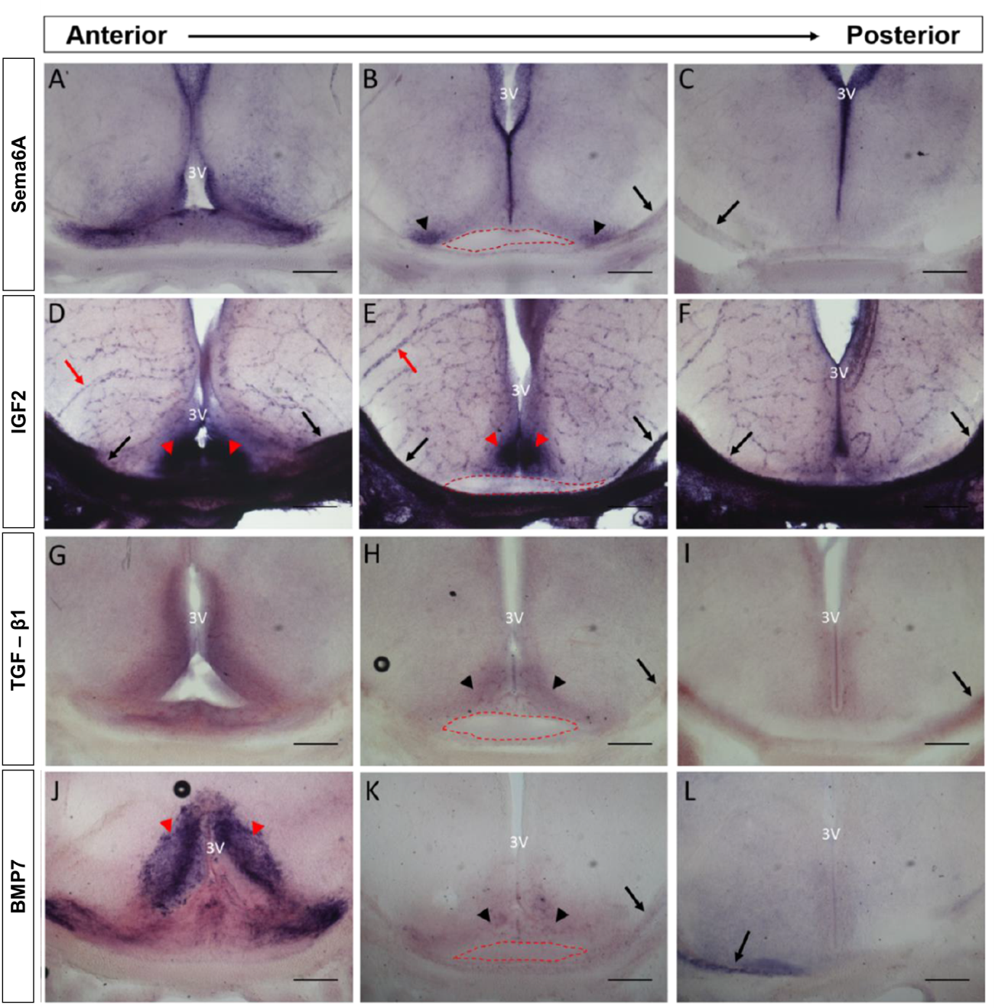

***Tgfb2***

***Bmp7***

***Igf2***

***Sema6a***

**Figure 2. Expression of meningeal factors in the developing ventral diencephalon.** *In situ* hybridisation with probes specific for *Sema6A*, *Igf2*, *Tgfb2*, and *Bmp7* at E15.5 in serial 100 µm coronal sections. Red dashed line indicates the optic chiasm region; black arrows expression in meninges; red arrows expression in blood vessels; black arrowheads expression around the optic chiasm; red arrowheads expression in the presumptive suprachiasmatic nuclei region. 3V – 3rd ventricle. Scale bars – 200 µm.

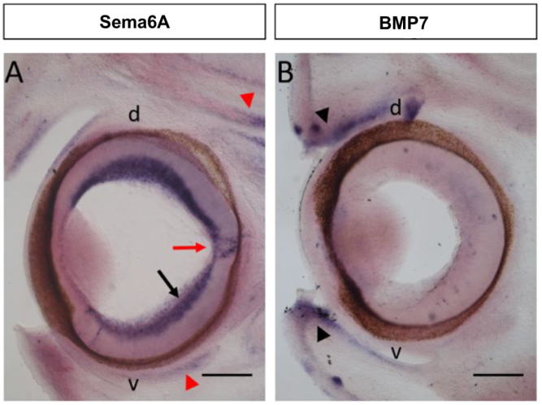

***Bmp7***

***Sema6a***

**Figure 3. Expression of *Sema6A* and *Bmp7* in the developing mouse eye.** *In situ* hybridization in 100 µm coronal sections through the E15.5 mouse eye with probes specific for *Sema6a* and *Bmp7*.Black arrow indicates expression in the retinal ganglion cell layer; red arrows expression in glial cells of the optic disc; red arrowheads expression in extraocular muscles, black arrowhead expression in the developing eyelids. Scale bar – 200µm. d – dorsal, v – ventral.

## Expression of *Igf2* and *Bmp7* in the presumptive suprachiasmatic nuclei

The expression patterns of *Igf2* and *Bmp7* suggested presence in the suprachiasmatic nuclei. To confirm this, we designed a novel protocol for double fluorescent *in situ* with the suprachiasmatic nucleus marker RAR-related orphan receptor alpha (*Rorα*) and either *Igf2* (Fig. 4) or *Bmp7* (Fig. 5). The *Bmp7* fluorescence showed expression pattern similar to the conventional *in situ* staining. There was pronounced expression in the presumptive suprachiasmatic nucleus area (Fig. 5 D) and the ventral meninges. The *Igf2* fluorescence also showed some resemblence to the conventional *in situ* indicating expression in the ventral meninges, the presumtive suprachiasmatic area and and lining of 3rd ventricle (Fig. 4 D-F). However, for both *Igf2* and *Bmp7* there was pronounced autofluorescence (especially in blood vessels). Unfortunately, the staining for *Rorα* did not work well (Fig. 4 G-H, Fig. 5 G-H) so no meaningful conclusions could be extracted from these data and modifications to the protocol are needed.

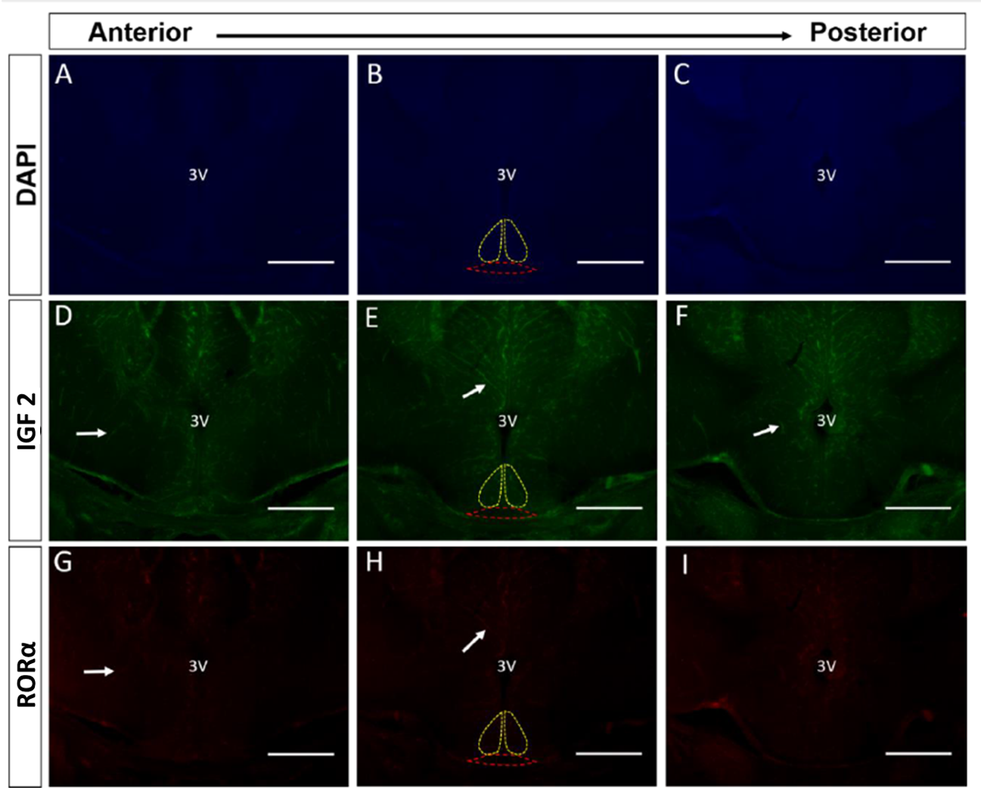

***Rorα***

***Igf2***

**DAPI**

**Figure 4. Double fluorescence *in situ* hybridisation of serial 100 µm coronal sections through the E15.5 ventral diencephalon with probes specific for *Igf2* (green)and the suprachiasmatic nucleus marker *Rorα* (red).** Sections were counterstained with DAPI (blue) to label cell nuclei. Presumptive suprachiasmatic nuclei area indicated by yellow dashed lines, optic chiasm region by red dashed lines, white arrows autofluorescence in blood vessels. 3V – 3rd ventricle. Scale bar – 200µm, E15.5.

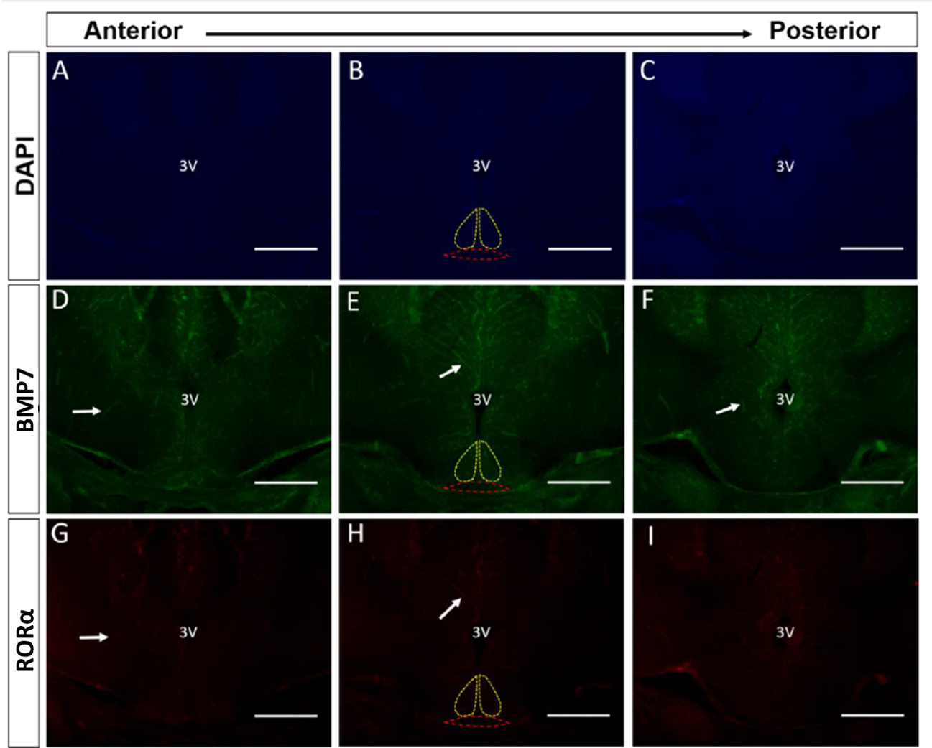

***Rorα***

**DAPI**

***Bmp7***

**Figure 5. Double fluorescence *in situ* hybridisation of serial 100 µm coronal sections through the E15.5 ventral diencephalon with probes specific for *Bmp7* (green)and the suprachiasmatic nucleus marker *Rorα* (red).** Sections were counterstained with DAPI (blue) to label cell nuclei. Presumptive suprachiasmatic nuclei area indicated by yellow dashed lines, optic chiasm region by red dashed lines, white arrows autofluorescence in blood vessels. 3V – 3rd ventricle. Scale bar – 200µm, E15.5.

## Other meningeal factors, weak *Sema3A* expression in the ventral meninges

Previous experiments in the lab had accumulated unanalyzed data for other meningeal factors with potential impact on the optic pathway namely: Semaphorin-3A (Sema3A), Slit3, Retinaldehyde dehydrogenase (Raldh1-3), and Retinol dehydrogenase 1 (Rdh1). For the analysis, coronal sections at age similar to E15.5 were needed in order for the data to be comparable to the one accumulated for *Sema6A*, *Igf2*, *Tgfb2* and *Bmp7*. Sufficient n number for those criteria was only available for *Sema3A* (Table 1). *Sema3A* was expressed weakly in the ventral meninges near the optic chiasm. There was no expression in the surrounding brain tissue (Fig. 5).

**Table 1. Analysis of existing data for other meningeal factors.** The number of analysed images was restricted by lack of images of appropriate sections and insufficient n numbers. Inclusion criteria in green, exclusion criteria in red.

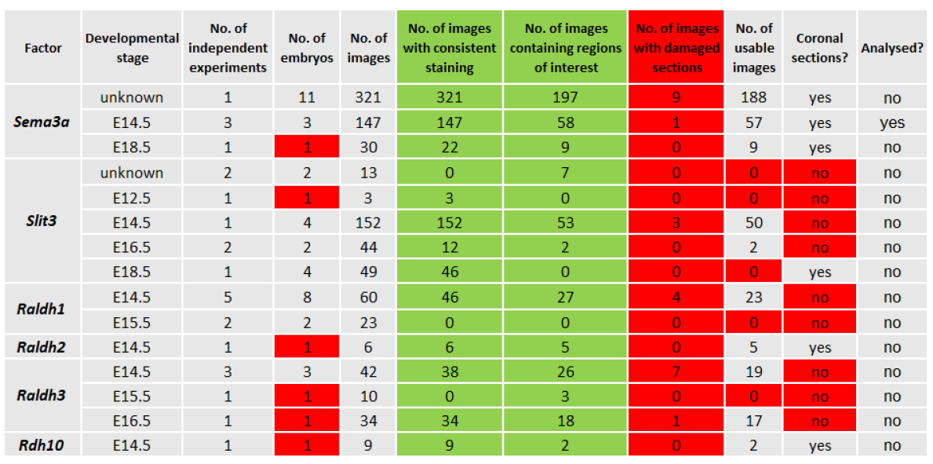

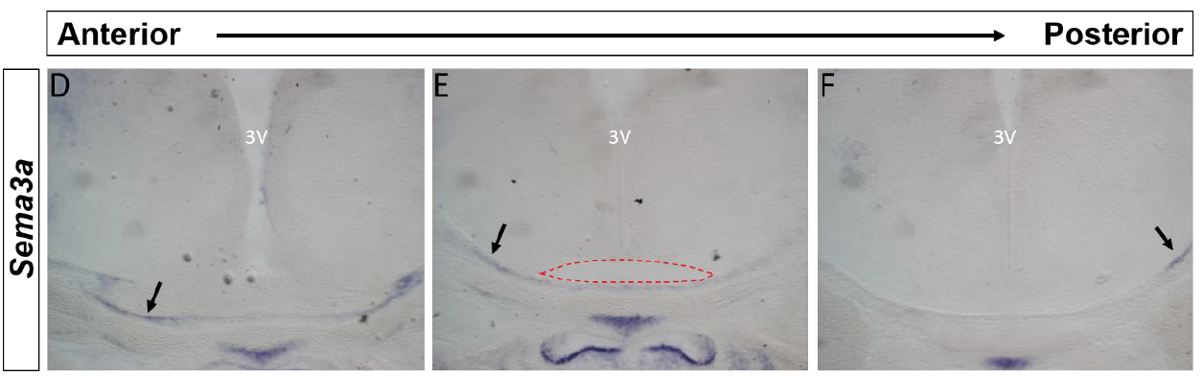

***Sema3a***

**Figure 6. Expression of semaphorin-3A (*Sema3a*) in the E14.5 mouse ventral diencephalon.** *In situ* hybridisation with probes specific for *Sema3A* in serial 100 µm coronal sections at E14.5. Black arrows indicate *Sema6A* expression in the meninges; red dashed line the optic chiasm region. 3V – 3rd ventricle, N=3, **pre-existing data**.

## Meninges did not influence axonal outgrowth in retinal explants culture

Finally, we investigated the direct effect of meningeal tissue on axonal outgrowth from the neural retina (Fig. 7). Retinal explants were obtained from E15.5 mouse embryos and cultured for 24 h on collagen gels either alone or at a short distance from meningeal (ventral diencephalon) explants from the same animals (Fig. 7 A). Retinal explants were obtained from the dorsotemporal (containing predominantly contralaterally projecting RGCs) and ventrotemporal (containing predominantly ipsilaterally projecting RGCs) region of the retina to control for RGC population specific effects. No significant difference between the outgrowth areas of ventrotemporal and dorsotemporal retinal explant was observed. Culturing explants of either region together with meningeal explants also lead to no significant change in outgrowth area compared to the no meninges condition (Fig. 7 D).

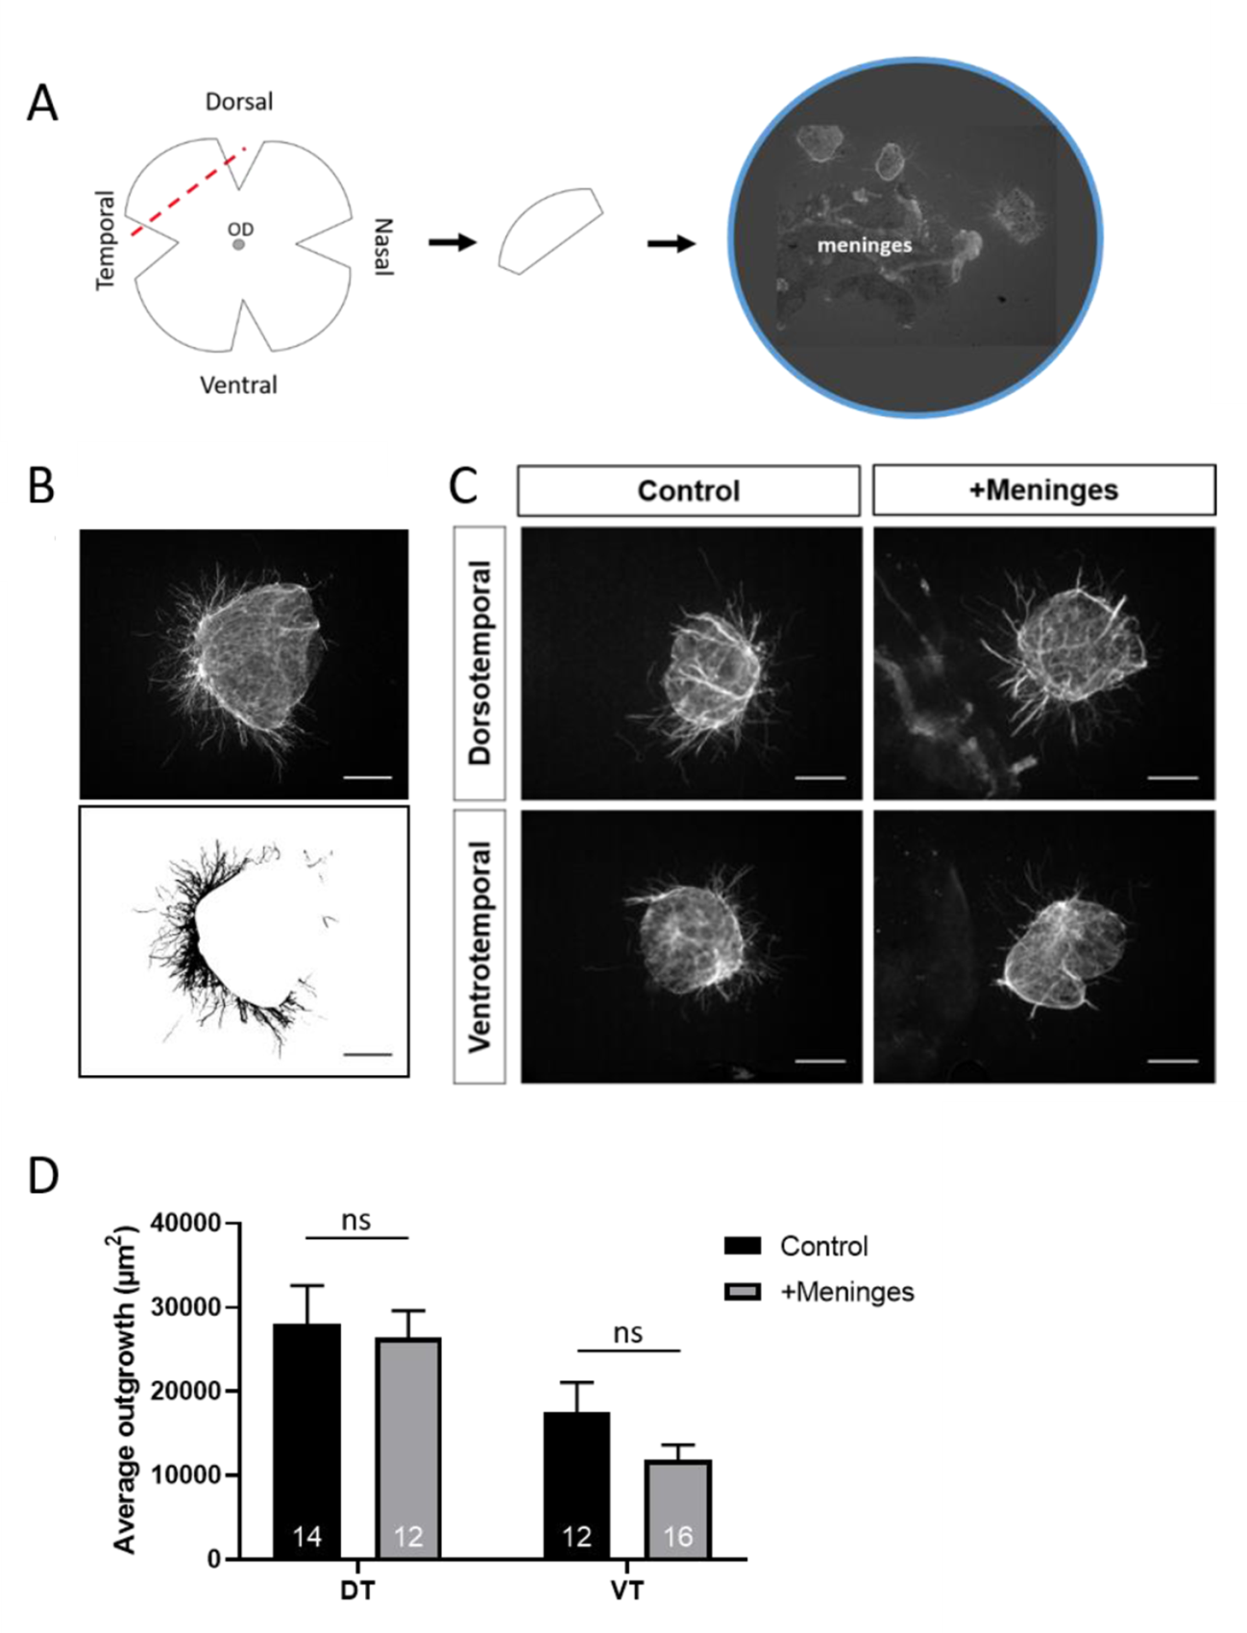

**Figure 7. Impact of meninges on retinal ganglion cell axon outgrowth *in vtiro*. A** – Experimental set up. Retinae were explanted, flattened and the peripheral dorsal temporal or ventrotemporal retina dissected and cultured in a collagen gel either alone or at a short distance (100 – 300 µm) from ventral diencephalon meninges from the same embryos. OD – optic disc. **B** – Image processing. Images were processed in ImageJ by subtracting the explant area and measuring outgrowth area. **C** – representative examples of ventrotemporal and dorsotemporal retinal explants cultured in the presence and absence of meninges. Scale bars (B, C) – 200µm. **D** – Mean ± s.e.m. axon outgrowth from dorsotemporal (DT) or ventrotemporal (VT) retinal explants cultured in the presence or absence of ventral diecenphalone meninges., Numbers on bars indicate numbers of explants analysed from 2 independent experiments. Normal distribution confirmed by Anderson-Darling normality test, p values calculated with one-way ANOVA. Ns – not significant.

# Discussion

Various guidance signals are required for correct brain development. Many developmental cues have been discovered, however one potential signalling vector, the meninges, is yet to be fully investigated. The meninges are highly vascularised and secrete variety of factors in close proximity to the developing brain suggesting they might play a role in guiding its development. The development of the optic pathway - a highly stereotypical, complex structure in close proximity to the ventral meninges was investigated.

Using *in situ* hybridisation, we looked at the expression of the meningeal factors: Igf2, Tgfb1, Bmp7 and Sema6A in mouse embryos coronal head sections to determine if they are expressed near the optic chiasm at the midpoint of its development (E15.5). Pre-existing data for other factors (Sema3A) in comparable set up (E14.5) was also analysed.

## Igf2, Tgfb1, Bmp7, Sema6a and Sema3a all expressed in the ventral meninges.

All factors except Sema3A were expressed in the ventral diencephalon adjacent to the optic chiasm. However, the staining Tgfb1 was inconsistent and given the limited n number further testing with a fresh probe would be required to confirm its expression. Most notably, Igf2, Tgfb1, Bmp7, Sema6A and Sema3A, were all expressed in the ventral meninges in close proximity to the optic chiasm. This is in line with the hypothesis that those factors are secreted from the meninges in a time and location that would make it possible for them to influence the optic chiasm formation.

Sema6a was expressed dorsal to the optic chiasm while Sema3a was found at the ventral surface, suggesting those two factors could be acting in combination to prevent axonal wandering ventrally and dorsally. Additionally, Sema3a repels glial precursor cells away from the optic chiasm (Sugimoto et al., 2001). The Sema receptor Neuropilin 1 is found in contralateral RGC axons, the crossing appears to be mediated by VEGF ligand (Erskine *et al.*, 2011) and point mutation preventing Sema binding of Neuropilin 1 does not lead to optic chiasm defects (Gu *et al.*, 2003).

It is important to also identify potential mechanisms and receptors. Bmp7 mutant mice have very severe eye and renal malformations (Dudley et al., 1995; Zouvelou et al., 2009). Bmp receptor 1b (Bmpr1b) is required for RGC cell survival and axon guidance in the retina (Liu, Wilson and Reh, 2003). Bmpr1b mutants exhibit eye malformations and reduced optic nerve size. However, Yan *et al.* (2020) using anterograde tracing and found no defects in the crossing and fasciculation of axons at the optic chiasm, suggesting Bmpr1b does not affect axon guidance at the chiasm.

Igf2 showed very strong expression in the diencephalon and the ventral meninges. Furthermore, Igf2 is preferentially expressed by in the peripheral retina (Trimarchi, Cho and Cepko, 2009) and was found to be enriched in ipsilateral RGC projections (Wang, Marcucci, Cerullo and Mason, 2016). Taken together those findings make Igf2 a very strong candidate for further investigation into optic chiasm guidance. Igf2 appears to be regulating proliferation of radial glial cells via the Igf1r (Lehtinen et al., 2011; Bracko et al., 2012), however igf2 also binds Igf2r and the Insulin receptor A which might be of interest.

## Igf2 and Bmp7 are expressed in the presumptive suprachiasmatic nucleus.

Igf2 and Bmp7 showed very strong expression in the ventral diencephalon. The expression pattern was similar in shape and location to the suprachiasmatic nuclei. The suprachiasmatic nuclei function as an internal clock. They are innervated by special subpopulation of RGCs – intrinsically photo sensitive retinal ganglion cells (ipRGCs) that are not involved in image formation but instead synchronise the circadian rhythm with the light dark cycle (Schmidt, Chen and Hattar, 2011). To the best of our knowledge there has been no report of Igf2 or Bmp7 role in the development of the suprachiasmatic nuclei.

To test whether Igf2 and Bmp7are in fact expressed in the suprachiasmatic nuclei at E15.5 we developed a novel protocol for double fluorescent in situ hybridisation staining. Rorα was used as suprachiasmatic nucleus marker expressed at E15 together with a probe for either Igf2 or Bmp7. Unfortunately, the staining for Rorα did not work well so no meaningful results could be extracted. Despite some auto-fluorescence, the Igf2 and Bmp7 fluorescence showed patterns similar to the conventional in situ method, suggesting that the fluorescent method works and repeating the experiment with fresh Rorα probe or switching to another suprachiasmatic nucleus marker (such Lhx) could give good results.

The suprachiasmatic nuclei in mice develop between E12 to E15 (Kabrita and Davis, 2008), however ipRGCs innervation only starts at birth. Therefore it seems unlikely Igf2 and Bmp7 are specific attractors of ipRGCs. They could be acting as placeholders inhibiting wrongful innervation by other cells. To check for a role of Igf2 and Bmp7 in ipRGCs innervation of the suprachiasmatic nuclei staining at the time around birth to check for expression changes would be recommended. Given the timing, it is also likely that Igf2 and Bmp7 are instead involved in the neuronal oscillations which begin at the suprachiasmatic nuclei at E15. Moreover, Igf2 has already been shown to be involved in oscillations in other parts of the hippocampus (Dellapolla et al., 2017).

## Meninges did not influence axonal outgrowth in retinal explants culture

There is growing evidence the meninges are involved in brain development. Meninges promote proliferation and survival of radial glial cells in the frontal cortex (Radakovits et al., 2009). Meningeal secreted factor SDF1 stimulates migration of Cajal-Retzius cells etc. Meninges derived signals also participate in axon guidance of motor neurons in the spinal cord (Suter, DeLoughery and Jaworski, 2017). To see whether the meninges would influence the growth of RGCs we performed retinal explants on E15.5 mice and cultured them either in the presence or absence of ventral meninges explants from the same mice. Previous data from the lab (Le Viet Hang, unpublished) showed significant increase in RGCs outgrowth from dorsonasal retinal explants in the presence of meninges compared to no meninges but no effect in the ventronasal explants. To expand on that data we used dorsotemporal and ventrotemporal explants for our experiment. No difference in outgrowth was observed in either dorsotemporal or ventrotemporal explants with or without meninges. It is possible the lack of effect was due to the limited n number. Another possibility is that the RGCs in the dorsonasal retina contain distinct receptors for some meningeal factor that is not present in RGCs in the rest of the retina.

## Further studies

Igf2, Tgfb1, Bmp7, Sema6A and Sema3A were expressed both in the ventral meninges and near the optic chiasm at the midpoint of its development. Further studies to identify the specific receptors for those factors that are expressed in the relevant location and time can give more light into their role in the optic chiasm. These could be followed by turning assays and specific knockout experiments. The Tgfb1 expression needs to be repeated for more consistent results before any conclusion could be made for that factor. The Igf2 and Bmp7 expression in the suprachiasmatic nuclei still needs to be confirmed by improvement of the fluorescent protocol. We did not see effect of the meninges, however larger sample size is required to make any meaningful conclusions.

# References

Altmann, C. and Brivanlou, A. (2001). Neural patterning in the vertebrate embryo. *International Review of Cytology*, 203, pp.447-482.

Arakawa, Y., Bito, H., Furuyashiki, T., Tsuji, T., Takemoto-Kimura, S., Kimura, K., Nozaki, K., Hashimoto, N. and Narumiya, S. (2003). Control of axon elongation via an SDF-1α/Rho/mDia pathway in cultured cerebellar granule neurons. *The Journal of Cell Biology*, 161(2), pp.381-391.

Augsburger, A., Schuchardt, A., Hoskins, S., Dodd, J. and Butler, S. (1999). BMPs as Mediators of Roof Plate Repulsion of Commissural Neurons. *Neuron*, 24(1), pp.127-141.

Bagnard, D., Lohrum, M., Uziel, D., Püschel, A. and Bolz, J. (1998). Semaphorins act as attractive and repulsive guidance signals during thedevelopment of cortical projections. *Development,* 125, pp.5043-5053.

Baker, J., Liu, J., Robertson, E. and Efstratiadis, A. (1993). Role of insulin-like growth factors in embryonic and postnatal growth. *Cell*, 75(1), pp.73-82.

Beck, H., Drahushuk, K., Jacoby, D., Higgins, D. and Lein, P. (2001). Bone morphogenetic protein-5 (BMP-5) promotes dendritic growth in cultured sympathetic neurons. *BMC Neuroscience*, 2(1), pp.12.

Birgbauer, E., Cowan, C. A., Sretavan, D. W., and Henkemeyer, M. (2000). Kinase independent function of EphB receptors in retinal axon pathfinding to the optic disc from dorsal but not ventral retina. *Development,* 127, pp.1231–1241.

Bracko, O., Singer, T., Aigner, S., Knobloch, M., Winner, B., Ray, J., Clemenson, G., Suh, H., Couillard-Despres, S., Aigner, L., Gage, F. and Jessberger, S. (2012). Gene Expression Profiling of Neural Stem Cells and Their Neuronal Progeny Reveals IGF2 as a Regulator of Adult Hippocampal Neurogenesis. *Journal of Neuroscience*, 32(10), pp.3376-3387.

Brittis, P. A., and Silver, J. (1995). Multiple factors govern intraretinal axon guidance: A time-lapse study. *Molecular and Cellular Neuroscience,* 6, pp.413–432.

Brittis, P. A., Canning, D. R., and Silver, J. (1992). Chondroitin sulfate as a regulator of neuronal patterning in the retina. *Science,* 255, pp.733–736.

Butler, S. and Dodd, J. (2003). A Role for BMP Heterodimers in Roof Plate-Mediated Repulsion of Commissural Axons. *Neuron*, 38(3), pp.389-401.

Campbell, D., Regan, A., Lopez, J., Tannahill, D., Harris, W. and Holt, C. (2001). Semaphorin 3A Elicits Stage-Dependent Collapse, Turning, and Branching in Xenopus Retinal Growth Cones. *The Journal of Neuroscience*, 21(21), pp.8538-8547.

Chalasani, S., Sabelko, K., Sunshine, M., Littman, D. and Raper, J. (2003). A Chemokine, SDF-1, Reduces the Effectiveness of Multiple Axonal Repellents and Is Required for Normal Axon Pathfinding. *The Journal of Neuroscience*, 23(4), pp.1360-1371.

Chalasani, S., Sabol, A., Xu, H., Gyda, M., Rasband, K., Granato, M., Chien, C. and Raper, J. (2007). Stromal Cell-Derived Factor-1 Antagonizes Slit/Robo Signaling In Vivo. *Journal of Neuroscience*, 27(5), pp.973-980.

Charron, F. and Tessier-Lavigne, M. (2005). Novel brain wiring functions for classical morphogens: a role as graded positional cues in axon guidance. *Development*, 132(10), pp.2251-2262.

Chen, D., Stern, S., Garcia-Osta, A., Saunier-Rebori, B., Pollonini, G., Bambah-Mukku, D., Blitzer, R. and Alberini, C. (2011). A critical role for IGF-II in memory consolidation and enhancement. *Nature*, 469(7331), pp.491-497.

Chesnutt, C., Burrus, L., Brown, A. and Niswander, L. (2004). Coordinate regulation of neural tube patterning and proliferation by TGFβ and WNT activity. *Developmental Biology*, 274(2), pp.334-347.

Cowey, A. and Perry, V. (1979). The projection of the temporal retina in rats, studied by retrograde transport of horseradish peroxidase. *Experimental Brain Research*, 35(3), pp 457–464.

Dasgupta, K. and Jeong, J. (2019). Developmental biology of the meninges. *Genesis*, 57(5), p.e23288.

Deiner, M., Kennedy, T., Fazeli, A., Serafini, T., Tessier-Lavigne, M. and Sretavan, D. (1997). Netrin-1 and DCC Mediate Axon Guidance Locally at the Optic Disc: Loss of Function Leads to Optic Nerve Hypoplasia. *Neuron*, 19(3), pp.575-589.

Dellapolla, A., Kloehn, I., Pancholi, H., Callif, B., Wertz, D., Rohr, K., Hurley, M., Baker, K., Hattar, S., Gilmartin, M. and Evans, J. (2017). Long days enhance recognition memory and increase insulin-like growth factor 2 in the hippocampus. *Scientific Reports*, 7(1).

Dudley, A., Lyons, K. and Robertson, E. (1995). A requirement for bone morphogenetic protein-7 during development of the mammalian kidney and eye. *Genes and Development*, 9(22), pp.2795-2807.

Erskine, L. and Herrera, E. (2014). Connecting the Retina to the Brain. *ASN Neuro*, 6(6), p.175909141456210.

Erskine, L., François, U., Denti, L., Joyce, A., Tillo, M., Bruce, F., Vargesson, N. and Ruhrberg, C. (2017). VEGF-A and neuropilin 1 (NRP1) shape axon projections in the developing CNS via dual roles in neurons and blood vessels. *Development*, 144(13), pp.2504-2516.

Erskine, L., Reijntjes, S., Pratt, T., Denti, L., Schwarz, Q., Vieira, J., Alakakone, B., Shewan, D. and Ruhrberg, C. (2011). VEGF Signaling through Neuropilin 1 Guides Commissural Axon Crossing at the Optic Chiasm. *Neuron*, 70(5), pp.951-965.

Erskine, L., Williams, S., Brose, K., Kidd, T., Rachel, R., Goodman, C., Tessier-Lavigne, M. and Mason, C. (2000). Retinal Ganglion Cell Axon Guidance in the Mouse Optic Chiasm: Expression and Function of Robos and Slits. *The Journal of Neuroscience*, 20(13), pp.4975-4982.

Escalante, A., Murillo, B., Morenilla-Palao, C., Klar, A. and Herrera, E. (2013). Zic2-Dependent Axon Midline Avoidance Controls the Formation of Major Ipsilateral Tracts in the CNS. *Neuron*, 80(6), pp.1392-1406.

Fukuda, Y., Sawai, H., Watanabe, M., Wakakuwa, K. and Morigiwa, K. (1989). Nasotemporal overlap of crossed and uncrossed retinal ganglion cell projections in the Japanese monkey (Macaca fuscata). *The Journal of Neuroscience*, 9(7), pp.2353-2373.

Garcia-Frigola, C., Carreres, M., Vegar, C., Mason, C. and Herrera, E. (2008). Zic2 promotes axonal divergence at the optic chiasm midline by EphB1-dependent and -independent mechanisms. *Development*, 135(10), pp.1833-1841.

Gu, C., Rodriguez, E., Reimert, D., Shu, T., Fritzsch, B., Richards, L., Kolodkin, A. and Ginty, D. (2003). Neuropilin-1 Conveys Semaphorin and VEGF Signaling during Neural and Cardiovascular Development. *Developmental Cell*, 5(1), pp.45-57.

Halfter, W., Reckhaus, W., and Kroger, S. (1987). Nondirected axonal growth on basal lamina from avian embryonic neural retina. *Journal of Neuroscience, 7*, 3712–3722.

Herrera, E., Erskine, L. and Morenilla-Palao, C. (2019). Guidance of retinal axons in mammals. *Seminars in Cell and Developmental Biology*, 85, pp.48-59.

Hopker, V. H., Shewan, D., Tessier-Lavigne,M., Poo, M., and Holt, C. (1999). Growth-cone attraction to netrin-1 is converted to repulsion by laminin-1. *Nature,* 401, pp.69–73.

Jeffery, G. and Erskine, L. (2005). Variations in the architecture and development of the vertebrate optic chiasm. *Progress in Retinal and Eye Research*, 24(6), pp.721-753.

Kabrita, C. and Davis, F. (2008). Development of the mouse suprachiasmatic nucleus: Determination of time of cell origin and spatial arrangements within the nucleus. *Brain Research*, 1195, pp.20-27.

Kaltcheva, M., Anderson, M., Harfe, B. and Lewandoski, M. (2016). BMPs are direct triggers of interdigital programmed cell death. *Developmental Biology*, 411(2), pp.266-276.

Kitraki, E., Bozas, E., Philippdis, H. and Stylianopoulou, F. (1993). Aging-related changes in IGF-II and c-fos gene expression in the rat brain. *International Journal of Developmental Neuroscience*, 11(1), pp.1-9.

Klein, R., Rubin, J., Gibson, H., DeHaan, E., Alvarez-Hernandez, X., Segal, R. and Luster, A. (2001). SDF-1 alpha induces chemotaxis and enhances Sonic hedgehog induced proliferation of cerebellar granule cells. *Development*, 128, pp. 1971-1981.

Kolpak, A., Zhang, J. and Bao, Z. (2005). Sonic Hedgehog Has a Dual Effect on the Growth of Retinal Ganglion Axons Depending on Its Concentration. *Journal of Neuroscience*, 25(13), pp.3432-3441.

LaVail, J., Tauscher, A., Aghaian, E., Harrabi, O. and Sidhu, S. (2003). Axonal Transport and Sorting of Herpes Simplex Virus Components in a Mature Mouse Visual System. *Journal of Virology*, 77(11), pp.6117-6126.

Lehtinen, M., Zappaterra, M., Chen, X., Yang, Y., Hill, A., Lun, M., Maynard, T., Gonzalez, D., Kim, S., Ye, P., D'Ercole, A., Wong, E., LaMantia, A. and Walsh, C. (2011). The Cerebrospinal Fluid Provides a Proliferative Niche for Neural Progenitor Cells. *Neuron*, 69(5), pp.893-905.

Lehtinen, M., Zappaterra, M., Chen, X., Yang, Y., Hill, A., Lun, M., Maynard, T., Gonzalez, D., Kim, S., Ye, P., D'Ercole, A., Wong, E., LaMantia, A. and Walsh, C. (2011). The Cerebrospinal Fluid Provides a Proliferative Niche for Neural Progenitor Cells. *Neuron*, 69(5), pp.893-905.

Leung, V., Iliescu, A., Jolicoeur, C., Gravel, M., Apuzzo, S., Torban, E., Cayouette, M. and Gros, P. (2015). The planar cell polarity protein Vangl2 is required for retinal axon guidance. *Developmental Neurobiology*, 76(2), pp.150-165.

Li, Q., Shirabe, K., Thisse, C., Thisse, B., Okamoto, H., Masai, I. and Kuwada, J. (2005). Chemokine Signaling Guides Axons within the Retina in Zebrafish. *Journal of Neuroscience*, 25(7), pp.1711-1717.

Liu, J., Wilson, S., and Reh, T. (2003). BMP receptor 1b is required for axon guidance and cell survival in the developing retina. *Developmental Biology,* 256, pp.34–48.

Marcos, S., Nieto-Lopez, F., Sandonis, A., Cardozo, M., Di Marco, F., Esteve, P. and Bovolenta, P. (2015). Secreted Frizzled Related Proteins Modulate Pathfinding and Fasciculation of Mouse Retina Ganglion Cell Axons by Direct and Indirect Mechanisms. *Journal of Neuroscience*, 35(11), pp.4729-4740.

Marín, O. and Rubenstein, J. (2003). Cell Migration in the Forebrain. *Annual Review of Neuroscience*, 26(1), pp.441-483.

Métin, C., Baudoin, J., Rakić, S. and Parnavelas, J. (2006). Cell and molecular mechanisms involved in the migration of cortical interneurons. *European Journal of Neuroscience*, 23(4), pp.894-900.

Oster, S., Bodeker, M., He, F. and Sretavan, D. (2003). Invariant Sema5A inhibition serves an ensheathing function during optic nerve development. *Development*, 130(4), pp.775-784.

Plump, A., Erskine, L., Sabatier, C., Brose, K., Epstein, C., Goodman, C., Mason, C. and Tessier-Lavigne, M. (2002). Slit1 and Slit2 Cooperate to Prevent Premature Midline Crossing of Retinal Axons in the Mouse Visual System. *Neuron*, 33(2), pp.219-232.

Polleux F., Giger R., Ginty D. and Ghosh A. (1998). Patterning of cortical efferent projections by semaphorin-neuropilin interactions. *Science,* 282, pp.1904-1906.

Radakovits, R., Barros, C., Belvindrah, R., Patton, B. and Muller, U. (2009). Regulation of Radial Glial Survival by Signals from the Meninges. *Journal of Neuroscience*, 29(24), pp.7694-7705.

Raper, J. (2000). Semaphorins and their receptors in vertebrates and invertebrates. *Current Opinion in Neurobiology*, 10(1), pp.88-94.

Rünker, A., Little, G., Suto, F., Fujisawa, H. and Mitchell, K. (2008). Semaphorin-6A controls guidance of corticospinal tract axons at multiple choice points. *Neural Development*, 3(1), pp.34.

Schmidt, T., Chen, S. and Hattar, S. (2011). Intrinsically photosensitive retinal ganglion cells: many subtypes, diverse functions. *Trends in Neurosciences*, 34(11), pp.572-580.

Song H., Ming G., He Z., Lehmann, M., McKerracher, L., Tessier-Lavigne, M. and Poo, M. (1998). Conversion of neuronal growth cone responses from repulsion to attraction by cyclic nucleotides. *Science,* 281, pp.1515-1518.

Stier, H., and Schlosshauer, B. (1995). Axonal guidance in the chicken retina. *Development*, 121*,* pp.1443–1454.

Stylianopoulou, F., Herbert, J., Soares, M. and Efstratiadis, A. (1988). Expression of the insulin-like growth factor II gene in the choroid plexus and the leptomeninges of the adult rat central nervous system. *Proceedings of the National Academy of Sciences*, 85(1), pp.141-145.

Sugimoto, Y., Taniguchi, M., Yagi, T., Akagi, Y., Nojyo, Y. and Tamamaki, N. (2001). Guidance of glial precursor cell migration by secreted cues in the developing optic nerve. *Development*, *128*(17), pp.3321–3330.

Suter, T., DeLoughery, Z. and Jaworski, A. (2017). Meninges-derived cues control axon guidance. *Developmental Biology*, 430(1), pp.1-10.

Thompson, H., Andrews, W., Parnavelas, J. and Erskine, L. (2009). Robo2 is required for Slit-mediated intraretinal axon guidance. *Developmental Biology*, 335(2), pp.418-426.

Thompson, H., Camand, O., Barker, D. and Erskine, L. (2006). Slit Proteins Regulate Distinct Aspects of Retinal Ganglion Cell Axon Guidance within Dorsal and Ventral Retina. *Journal of Neuroscience*, 26(31), pp.8082-8091.

Torre, J. R., Hopker, V. H., Ming, G. L., Poo, M. M., Tessier-Lavigne, M., Hemmati-Brivanlou, A. and Holt, C. (1997). Turning of retinal growth cones in a netrin-1 gradient mediated by the netrin receptor DCC. Neuron, 19, pp.1211–1224.

Trimarchi, J., Cho, S. and Cepko, C. (2009). Identification of genes expressed preferentially in the developing peripheral margin of the optic cup. *Developmental Dynamics*, 238(9), pp.2327-2329.

Wang, Q., Marcucci, F., Cerullo, I. and Mason, C. (2016). Ipsilateral and Contralateral Retinal Ganglion Cells Express Distinct Genes during Decussation at the Optic Chiasm. *Eneuro*, 3(6).

Xiang, Y., Li, Y., Zhang, Z., Cui, K., Wang, S., Yuan, X., Wu, C., Poo, M. and Duan, S. (2002). Nerve growth cone guidance mediated by G protein–coupled receptors. *Nature Neuroscience*, 5(9), pp.843-848.

Yam, P. and Charron, F. (2013). Signaling mechanisms of non-conventional axon guidance cues: the Shh, BMP and Wnt morphogens. *Current Opinion in Neurobiology*, 23(6), pp.965-973.

Yan, X., Atorf, J., Ramos, D., Thiele, F., Weber, S., Dalke, C., Sun, M., Puk, O., Michel, D., Fuchs, H., Klaften, M., Przemeck, G., Sabrautzki, S., Favor, J., Ruberte, J., Kremers, J., de Angelis, M. and Graw, J. (2020). Mutation in Bmpr1b Leads to Optic Disc Coloboma and Ventral Retinal Gliosis in Mice. *Investigative Opthalmology and Visual Science*, 61(2), p.44.

Ziegler, A., Chidambaram, S., Forbes, B., Wood, T. and Levison, S. (2014). Insulin-like Growth Factor-II (IGF-II) and IGF-II Analogs with Enhanced Insulin Receptor-a Binding Affinity Promote Neural Stem Cell Expansion. *Journal of Biological Chemistry*, 289(8), pp.4626-4633.

Ziegler, A., Schneider, J., Qin, M., Tyler, W., Pintar, J., Fraidenraich, D., Wood, T. and Levison, S. (2012). IGF-II Promotes Stemness of Neural Restricted Precursors. *STEM CELLS*, 30(6), pp.1265-1276.

Zouvelou, V., Luder, H., Mitsiadis, T. and Graf, D. (2009). Deletion of BMP7 affects the development of bones, teeth, and other ectodermal appendages of the orofacial complex. *Journal of Experimental Zoology Part B: Molecular and Developmental Evolution*, 312(4), pp.361-374.